**Module 1: Introduction**

**Module2 : Software Security**

**Module3 : Wireless Security**

**Module4 : Cloud Security**

**Module5 : Web Security**

**Module6 : Security and Risk Management**

##### **Module 1: Introduction**

**Authentication Process:**

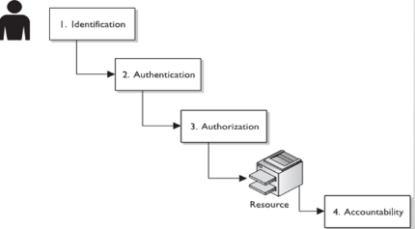

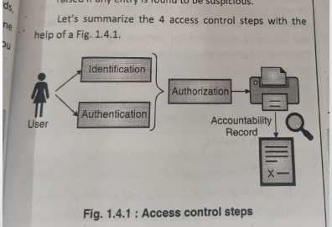

1. Identification

* a way to claim an entity’s presence with respect to the process being carried out.
* Ex: Email, phone no. Aadhaar card, Pan card, voter id, admit card, debit card

1. Authentication:

* It is a term that refers to the process of proving that some fact or some document is genuine.
* In computer science, this term is typically associated with proving a
* user’s identity. Usually, a user proves their identity by providing their credentials, that is, an agreed piece of information shared between the user and the system.

1. Authorisation

* A way to determine what resource an entity can access

1. Accountability

* Is a way to record your actions

1. Non-repudiation

* Is a way to prove your actions

**Authentication Methods:**

1. Something you know

* Password, PIN, secret question – mother’s maiden name, Pet name, first car purchase year, school name, city

1. Something you have

* Physical keys, badge, swipe card, digital certificate, security keys(private key), OTP, token

1. Something you are

* Biometrics : Fingerprint, palm scan, hand geometry, retina scan, iris scan, facial recognition

1. Something you do

* Dynamic biometrics: Voice print, keystroke dynamics(hard press/ fast press) , handwriting

1. Somewhere you are

* Location awareness(mobile phone, laptop)
* Google smart lock for Android (you can set trusted locations

**Factors of Authentication**

Single Factor Authentication:

* Requires only one type
* Password, token, debit card, PIN
* Weak form of authentication

Two-factor Authentication:

* Two forms
* Any single followed by otp

Multi-factor Authentication:

* More than two types

**Types of authentication**

1. Password based

Attacks on password-based auth

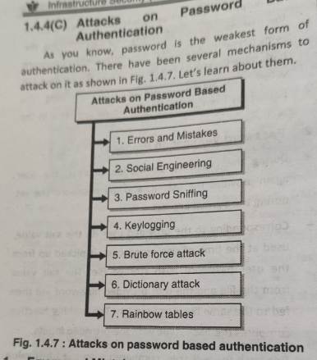

1. Token based

* Token device, or password generator, is usually a handheld device that has an LCD display and possibly a keypad
* Token device is separate from the computer the user is attempting to access

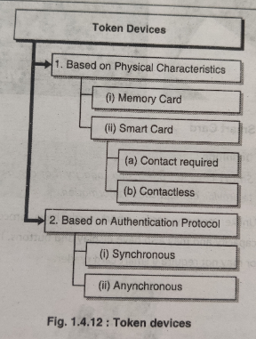

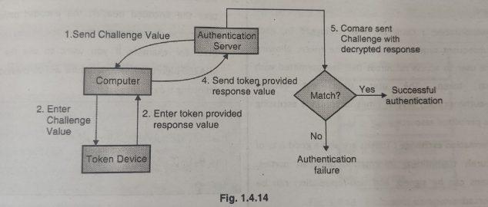

Benefits:

* Not vulnerable to electronic eavesdropping
* Wiretapping
* Sniffing
* Provide two factor authentication

Limitations:

* Human error
* Battery limitation
* Token itself (Environmental factors)

1. Biometric Based Authentication

Biometric Components:

* User interface
* Sensor(Fingerprint, Iris, etc)
* Processing unit
* storage
* **Access control policies**Protecting what needs to be protected with the available technologies!
* Access control is the ❤️ of Information Security!
* The right Flow of information between subject and
* object
* Mechanism to protect the assets!

**Frameworks of access control**

1. Discretionary Access Control (DAC)

* Allows the owner of the resource to specify which subjects can access which resources
* Access control is at the discretion of the owner
* DAC defines access control policy That restricts access to files and other system resources based on identity
* DAC can be implemented through Access Control Lists (ACLs)

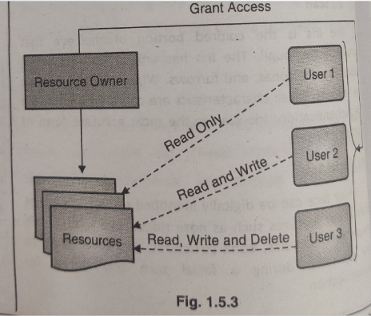

Advantages:

* Easy to understand
* Easy to implement
* Flexibility to assign/ revoke rights on the individual basis.

Disadvantages:

* Careful evaluation and administration of each resource, user and her rights periodically
* Once permission given, the user will have an unrestricted access
* If a user mistakenly installs a malware program, the malware will inherit all the DAC permissions that were assigned to the user.
* As the no. of users increase, it will become difficult to manage them and provide individual access right to each one of them.

1. Mandatory Access Control (MAC)

* MAC is considered a policy based control
* This restricts access to system resources based on their sensitivity and the authorization level of the entity trying to access the resources
* Used where confidentiality is of utmost importance
* Every object and subject is given a sensitivity label
* Classification level(High → Low level): Top secret, Secret, Confidential, sensitive, unclassified etc
* If the security label of the requested resource is lower or equal to the clearance level of the requesting entity then the access is provided.
* If the security label of the requested resource is higher than the clearance level of the requesting entity then the access is rejected.
* As a rule, an entity (person/ device) is allowed to access resources that are marked with a security label lower or equal to its own clearance level.

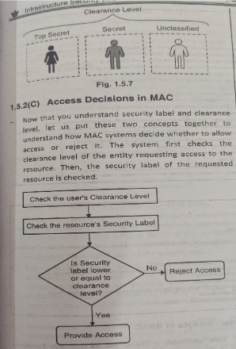

Advantages:

* All resources on the system are adequately labelled
* Access decisions are automatic based on the clearance level
* System-wide enforcement
* It is scalable model, individual users are not required to provide access rights.

Disadvantages:

* Inflexible to provide any specialized access
* Difficult o understand as compared to DAC

1. Role Based Access Control (RBAC)

* RBAC is an access control model for controlling access to resources where permitted actions on resources are identified with roles rather than with individual subject identities.
* On a windows platform users can be defined with their roles by the administrator
* And the roles can be hierarchical. Admin level people vs. guest level
* A user may also be assigned more than one role on a system

Advantages:

* Roles fit more naturally to the job function rather than the individual (bank/hospital/insurance)
* Easy administration- employees can leave and go without needing to change the defined rights for a given role

Disadvantages:

* Not all systems support fully functional RBAC capability
* There are various job functions performed by individuals in an organization. It is complex to define precise role requirement for each task and manage them

1. Attribute-Based Access Control(ABAC)

* In ABAC access is decided by the policy enforced on subject and object attributes.
* Types of attributes:
  1. Subject Attributes
  2. Object Attributes
  3. Environment Attributes

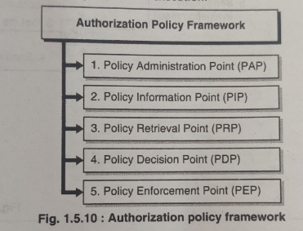

1. PAP : general administration like defining new policies, editing, deleting
2. PIP : provides attribute values for subjects, resources and environment
3. PRP: a database where policies are stored
4. PDP : if then else rules
5. PEP : receive all access requests for accessing resources

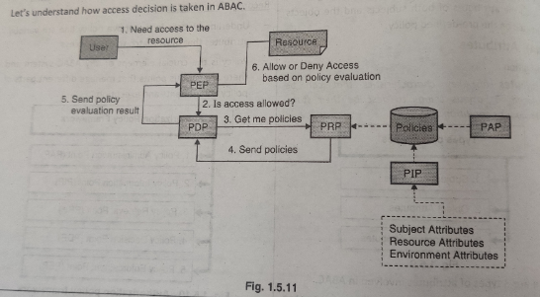

Advantages:

* Flexible to give permissions at the granular level Conditions
* Scalable
* permissions can be granted in dynamic way, and also can be extended to external users

Disadvantages:

* Requires investment in infrastructure
* Need to manage policies separately and periodically update

**Security Models:**

1. Bell-LaPadula Model

* This is used to maintain the Confidentiality of Security.
* Is a state machine model which ensures confidentiality aspect of access control and was developed in 1970’s
* For the US military to avoid disclosure of sensitive information.
* Has four components

1. Subjects
2. Objects
3. Actions (r,w)
4. Security levels (top secret, secret, confidential, sensitive and unclassified)

* Bell-LaPadula Model Rules
  + 1. Simple Security Rule: A subject **cannot read** an **object at a higher security level** than itself

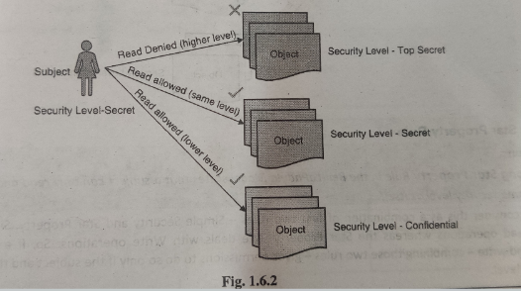

* + 1. Star Property Rule: A subject **cannot write** to an **object at a lower security level** than itself

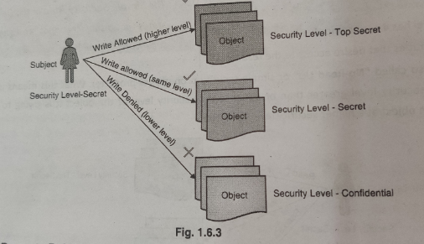

* + 1. Strong Star Property Rule: A subject can **only read and write to an object at a the same security level** as itself.

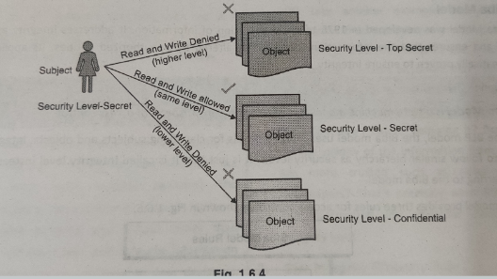

* + 1. Discretionary Security Property: A **subject can provide access to other subjects** based on its own judgment. The access for those subjects would still follow the security level-based rules of the model.

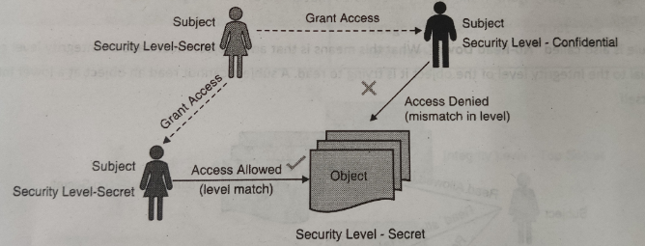

1. Biba Model

* This is used to maintain the Integrity of Security.
* Unlike the BLP model, this uses integrity levels for classifying subjects and objects.
* Three rules for access control
  + 1. Simple Integrity rule: A subject cannot read an object at a lower integrity level than itself. **(NO-Read Down)**

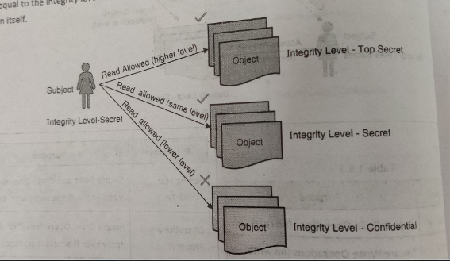

* + 1. Star Integrity property rule: A subject cannot write to an object at a higher integrity level than itself. **(NO-Write UP)**

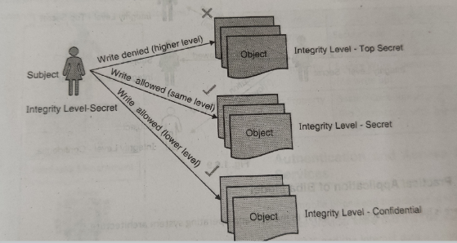

* + 1. Invocation Property Rule: A subject **cannot communicate with another subject at a higher integrity level** than itself.

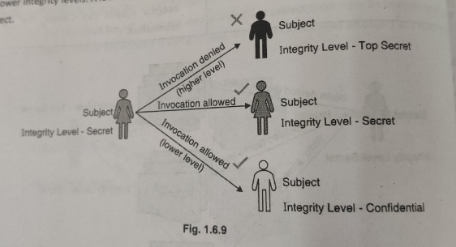

**What is Infrastrcuture and IS?**

Infrastructure is an asset which, like other important business assets, has value to an

organization and consequently needs to be suitably protected

IS:

* The architecture where an integrated combination of appliances, systems and solutions, software, alarms, and vulnerability scans working together
* Monitored 24x7
* Having People, Processes, Technology, policies, procedures,
* Security is not only for appliances or devices nut for PPT also
* Protects Infrastructure from a range of threats
* Ensures business continuity
* Minimizes financial loss
* Optimizes return on investments
* Increases business opportunities

WHat is CIA? / 5 Pillars of Information Assurance

* Confidentiality: Ensuring that Infrastructure is accessible only to those authorized to have access
* Intergrity: Safeguarding the accuracy and completeness of Infrastructure and processing methods
* Availability: Ensuring that authorized users have access to Infrastructure and associated assets when required

CIA + Neeche ke 2 for 5 pillar of info assurance

* Authentication:
* Non-Repuditation:

##### **Module 5: Web Security**

**OWASP Security Risks 2021 List**

1. Broken Access Control
2. Cryptographic Failures
3. Injection
4. Insecure Design
5. Security Misconfiguration
6. Vulnerable and Outdated Components
7. Identification and Authentication Failures
8. Software and Data Integrity Failures
9. Security Logging and Monitoring Failures
10. Server-Side Request Forgery (SSRF)

**What should be done for Web Security?**  
1. User Authentication

Types of Authentication

* HTTP Basic Authentication
* HTTP Digest Authentication
* Form based Authentication

2. Session Management

Parameter

* Session ID
* Cookies
* Session Expiry

3. Secure Socket Layer

Advantages

* Security
* Reliability
* SEO
* Software Requirements

Disadvantages

* Cost
* Expiry
* Performance

Working based on Public-private key pair

Types of SSL Certificates

* Extended Validation (EV) Certificates
* Organization Validation (EV) Certificates
* Domain Validation (EV) Certificates

4. HTTPS

Methods

* GET
* HEAD
* POST
* PUT

HTTP 1.1

HTTP 2

5. Secure Socket Shell (SSH)

* Cryptographic network protocol that is used for transferring encrypted data over network.
* Allows you to connect to a server, or multiple servers, without having you to remember or enter your password for each system that is to login remotely from one system into another.
* When you connect through SSH, you will be dropped into a shell session, which is a text-based interface where you can interact with your server.
* For the duration of your SSH session, any commands that you type into your local terminal are sent through an encrypted SSH tunnel and executed on your server.
* SSH connection is implemented using a client-server model.
* For an SSH connection to be established, the remote machine must be running a piece of software called an SSH daemon.

6. Privacy on the Web

**Web Browser Attacks**

Types

Drive-by Downloads

Plugins & Extensions

Clickjacking

Man in the Browser

Web Bugs

Cross-site request forgery (CSRF)

Session Hijacking

DNS Attacks

Types:

* DNS Flood
* DNS Cache Poisoning
* DNS Poisoning/ DNS Hijacking
* DNS Spoofing

**Secure Electronic Transfer**

Early communications protocol used by e-commerce websites to secure electronic debit and credit card payments

**Email Attacks**

Phishing

Spear Phishing (research about individual and then attack)

Vishing (human emotions attack)

Smishing (SMS)

Whaling (Mails appear to be from trusted sources)

Spam

**Different Techniques for Phishing**

Spear Phishing

Session Hijacking

Email Spam

Content Injection

Web Based Delivery

Phishing through Search Engines

Vishing and Smishing

Link Manipulation

**Pharming**

Redirection of web traffic from a legitimate site to a fake site for the

purpose of stealing usernames, passwords, financial data, and other personal information.

Types

* Pharming Malware
* DNS Poisoning

**Web Services Security**

Authentication

Authorization (or Access Control)

Confidentiality, Privacy

Integrity, non repudiation

Transport Level Security (using SSL)

**Penetration Testing**

Stages

* Planning and Reconnaissance
* Scanning
* Gaining Access
* Analysis

Methods

* External Testing
* Internal Testing
* Blind Testing
* Double Testing
* Targeted Testing

Categories

* Black Box Testing
* White Box Testing
* Grey Box Testing

Frameworks used

* OSSTMM
* NIST

##### **MOD 4**

**What is Cloud Computing?**

Cloud computing is the on-demand availability of computer system resources, especially data storage and computing power, without direct active management by the user.

**Features of Cloud Computing**

* Resource Pooling
* On-Demand Self-Services
* Easy Maintenance
* Large network Access
* Availability
* Automatic System
* Economical
* Security
* Pay As You Go
* Measured Service

**Types of Cloud Services**

* Email
* Storage, Backup and data retrieval
* Creating and testing apps
* Analyzing data
* Audio and video streaming
* Delivering software on demand

**What’s Driving Cloud Computing?**

* Thought leaders
* The economy
* The Feds

**Cloud Computing Models**

* Deployment Model
  + Public Cloud
  + Hybrid Cloud
  + Private Cloud
* Service Model
  + Iaas
  + Paas
  + SaaS

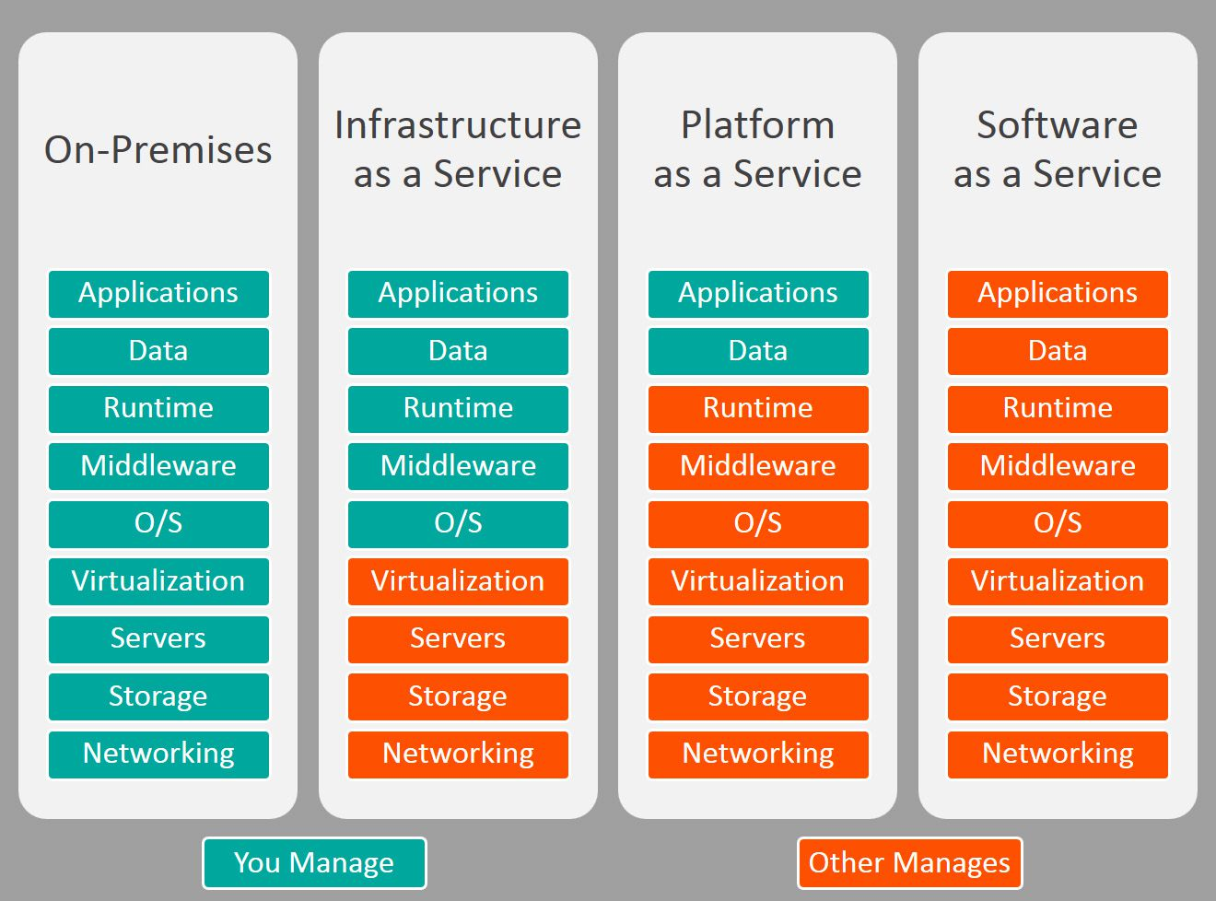

* Public Cloud
* Private Cloud
* Community Cloud
* Hybrid Cloud

**Cloud Computing Entities**

* Cloud Customer
* Cloud Provider
* Cloud Auditor
* Cloud Carrier
* Cloud Broker

**Cloud Computing Challenges**

* Security
* Performance
* Availability
* Hard to integrate with in-house IT
* Not enough ability to customize
* Worried on-demand will cost more
* Regulatory requirements prohibit cloud
* Not enough major suppliers yet

**What is Cloud Computing Security?**

**SECURITY RISKS IN CLOUD COMPUTING**

* Data Loss
* Interference of Hackers and Insecure API’s –
* Data breaches
* Compliance Violations & Regulatory Actions
* Hacked Interfaces
* Malware Injections
* Identity management & weak authentication
* Abuse and nefarious use of Cloud Services
* Changing Service Provider
* DOS
* Shared Resources
* Compliance and legal issues
* Data Encryption

Issues with the Choice of Cloud Provider

Issues with Cloud Provider Location

COUNTERMEASURES

* Data Encryption
* Use of Antivirus
* Strong Authentication
* Check Security Measures
* Define Policies Before Sharing Data
* Avoid Saving Crucial or Sensitive Data on Cloud

DATA PROTECTION IN CLOUD

* Data confidentiality assurance
* Data integrity protection
* Guarantee of data availability
* Secure data access
* Regulations and compliances
* Service audition

Cloud Identity and Access Management

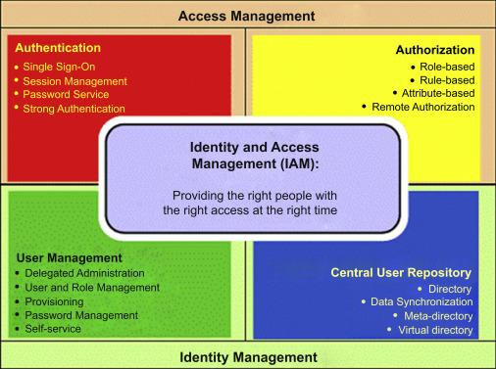

Features of Cloud IAM are:

* Single access control interface
* Fine-grained control
* Automated access control recommendations
* Context-aware access
* Flexible roles
* Built-in audit trail

IAM from major Cloud Providers are:

* Amazon
* Google
* IBM

CLOUD SECURITY AS A SERVICE

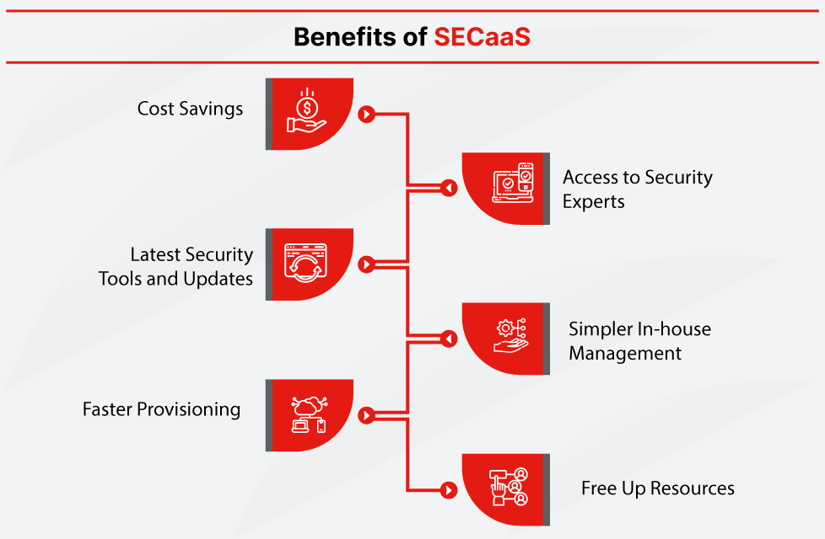

Some examples of SECaaS services include:

* Data loss prevention (DLP)
* Continuous monitoring
* Disaster recovery
* Business continuity
* Identity and access management (IAM)
* Encryption
* Email security
* Security assessment
* Network security
* Intrusion management
* Web security
* Vulnerability scanning
* Security information and event management (SIEM)

How to Choose a Security as a Service Provider

* Availability
* Fast Response Time
* Disaster Recovery Planning
* Vendor Partnerships

Cloud Application Security

##### **Module 3: Wireless Security**

**Mobile Device security**

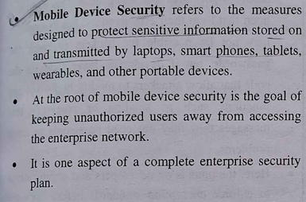

**Security threats:**

1. Data Leakage
2. Unsecured WiFi
3. Network Spoofing
4. Phishing attacks
5. Spyware
6. Broken Cryptography
7. Malware
8. Outdated OS
9. Untested Mobile Apps
10. Device Loss
11. Advanced Persistent threats

**Strategies for Mobile Device security**

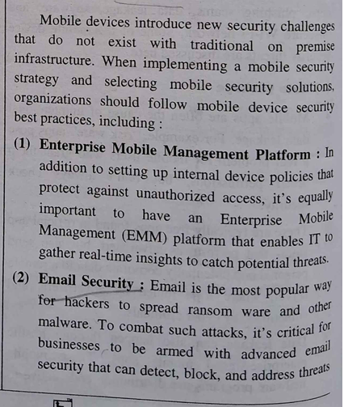

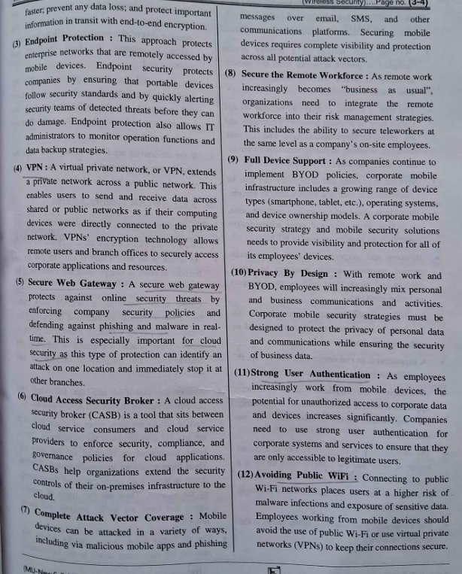

**IEEE 802.11x Wireless LAN Security**

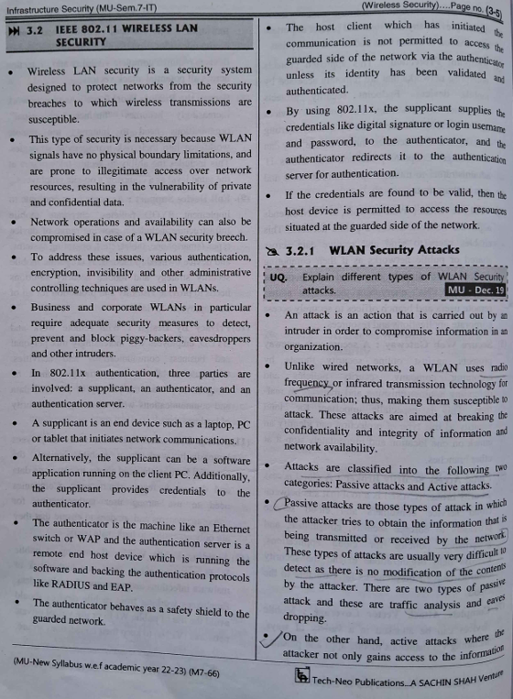

**Based on CIA triad, access control and authentication definitions various types of attacks are:**

1. **Confidentiality attacks**

* Traffic Analysis
* Eavesdropping
* Man in the middle attack

1. **Integrity attacks**

* Session Hijacking
* Replay attack
* 802.11 Frame Injection attack

1. **Availability attacks**

* DoS
* Radio Frequency jamming
* Fake SSID

1. **Authentication attacks**

* Shared key guessing
* PSK cracking
* Application login theft
* VPN login cracking
* Domain Login cracking

1. **Access control attacks**

* MAC address spoofing
* Unauthorized access
* War driving
* Rogue access point

**VPN Security**

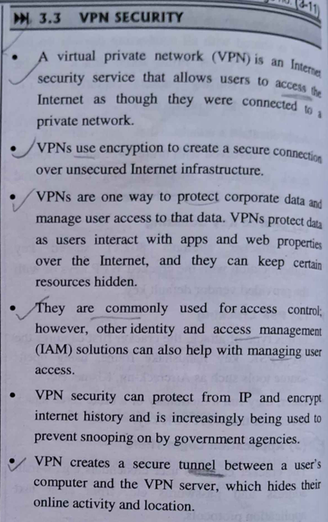

**Types of VPN**

1. Remote access VPN
2. Site to Site VPN

-Intranet VPN

- Extranet VPN

1. Client-to-Server VPN
2. P2P VPN
3. Single-Protocol VS Multi Protocol VPN

**Drawbacks of using VPNs for Access Control**

1. Single point of failure
2. VPNs are unwieldy to manage
3. VPNs are not granular

**Wireless Intrusion Detection System (WIDS)**

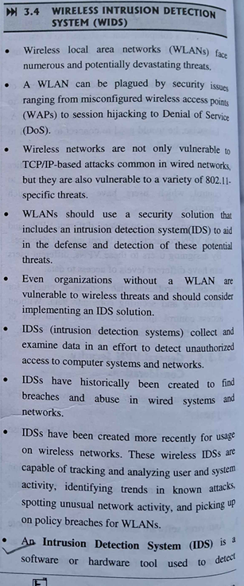

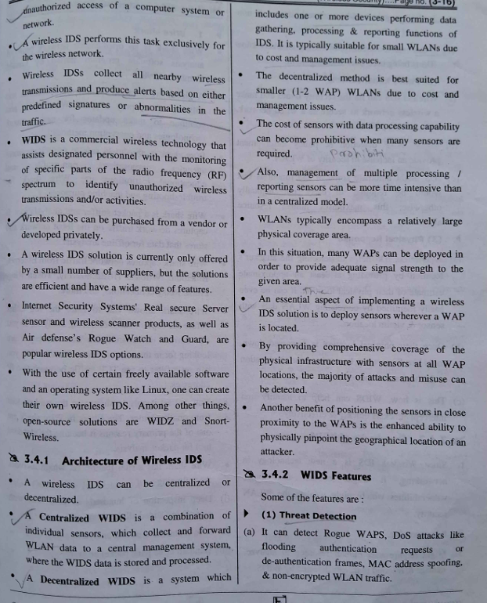

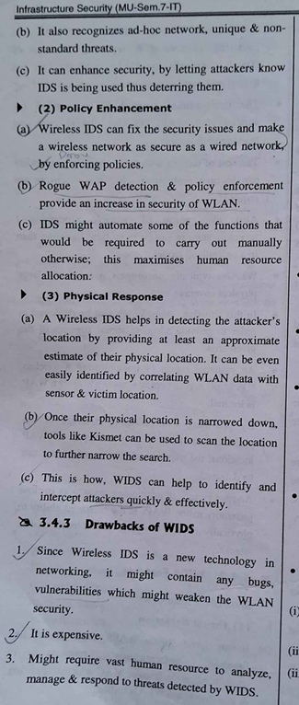

##### **Mod 2**

Software Security Memory and Address Protection, File Protection Mechanism,

User Authentication

**Database Security Requirements**

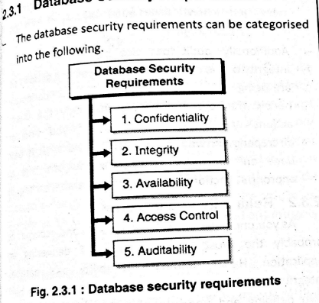

**Reliability and Integrity**

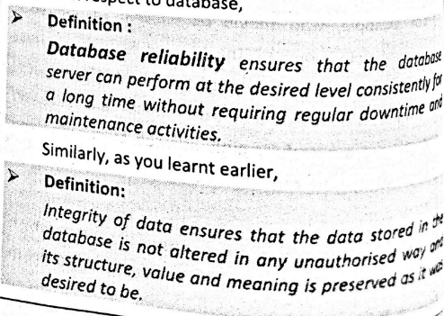

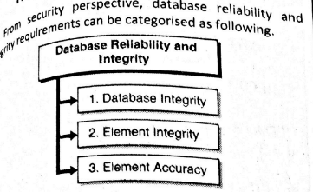

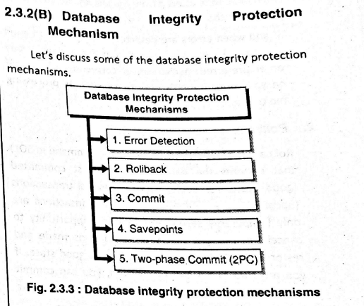

**Sensitive Data**

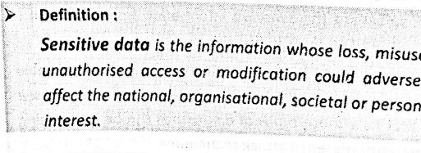

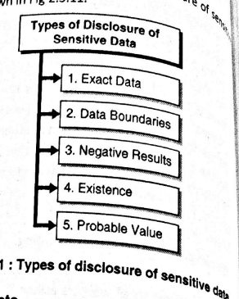

**Inference Attacks**

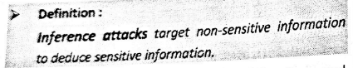

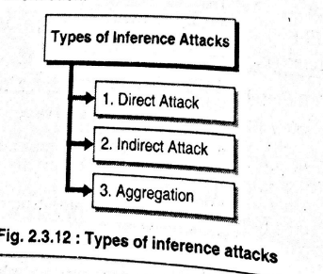

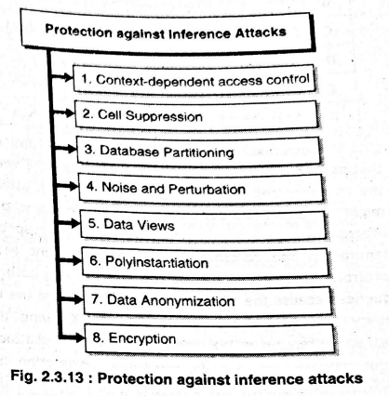

**Multilevel Database Security**

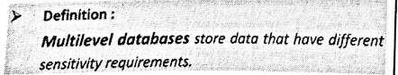

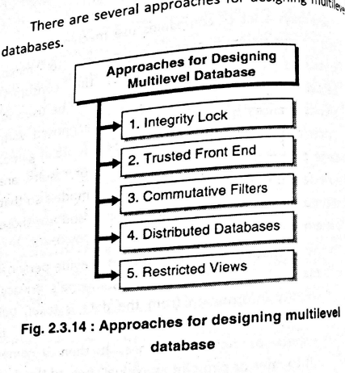

##### **Module 6: Information Security & Risk Management**

**What are Security Policies?**

A document that states in writing how a company plans to protect its physical and information technology (IT) assets.

Living documents that are continuously updated

**Importance of Security Policies**

They protect an organizations' assets, both physical and digital.

They identify all company assets and all threats to those assets

**Physical Security Policies:** protecting a company's physical assets, such as buildings and equipment, including computers and other IT equipment.

**Data security policies:** protect intellectual property from costly events, like data breaches and data leaks.

**Characteristics of Policies**

* Driven by organization's Mission and objectives
* Clearly expressed and unambiguous
* Adhere to local and global laws and regulations
* Future looking
* Clearly define Role and responsibilities
* Version controlled and protected from unauthorized modification
* Periodically reviewed, audited and checked for compliance or non-compliance
* Repeatedly communicated to all stakeholders

**Types of Security Policies**

* **Organizational.** These policies are a master blueprint of the entire organization's security program.
* **System-specific.** A system-specific policy covers security procedures for an information system or network.
* **Issue-specific.** These policies target certain aspects of the larger organizational policy.

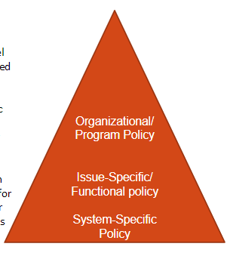

**Examples of Policies**

Virus and Spyware Protection Policy

LiveUpdate Policy

Firewall Policy

Intrusion Prevention Policy

Application and Device Control

Host Integration Policy

**Types of Security Policies**

* **Advisory Policy:** Advisory policy strongly advises employees on the behaviors and activities which should and should not take place within the organization.
* **Regulatory Policy:** Regulatory policy ensures that the organization is following standards set by specific industry regulations.
* **Informative Policy:** The purpose of which is to communicate information to a specific audience.

**Policies, Standards, Guidelines and Procedures**

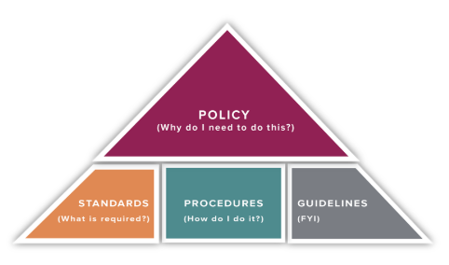

* GUIDELINES

General statements, recommendations, or administrative instructions designed to achieve the policy’s objectives by providing a framework to implement procedures.

* PROCEDURES

Procedures are the operational processes necessary to implement institutional policy and describe the process: who does what, when they do it, and under what criteria.

* STANDARDS

A mandatory action or rule designed to support and conform to a policy.

* POLICY

A formal, high-level statement with broad application throughout the Organisation / Institute designed to promote operational efficiencies, enhance the Organisation's mission, or reduce institutional risk.

**Risk Analysis**

Risk = Probability of something going wrong + Negative consequences if it does

Risk Analysis is a process that helps you identify and manage potential problems that could undermine key business initiatives or projects.

Process

* Identity Assets
* Determine Vulnerabilities
* Analyse Risks
* Analyse Existing security controls
* Estimate likelihood of Exploitation- Rare, Unlikely, Possible, Likely, Almost Certain
* Determine Impact of Risk- Insignificant, Minor, Moderate, Major, Catastrophic, Doomsday.
* Determine Level of Risk: Extreme, High, Medium, Low.
* Compute Expected Annual Loss
* Document the Results
* Evaluate Risks
* Risk Treatment
* Survey applicable controls and their costs
* Project costs and savings

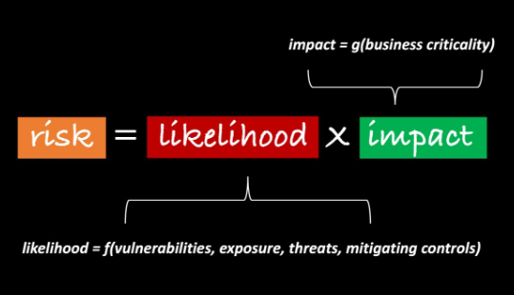

**Threat, Risk & Vulnerability**

Vulnerability is a flaw or weakness in an asset’s design, implementation, or operation and management that could be exploited by a threat.

A threat is a potential for a threat agent to exploit a vulnerability.

A risk is the potential for loss when the threat happens.

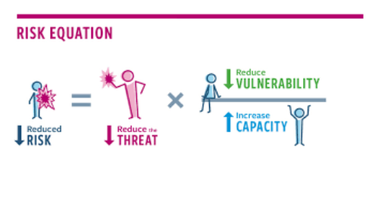

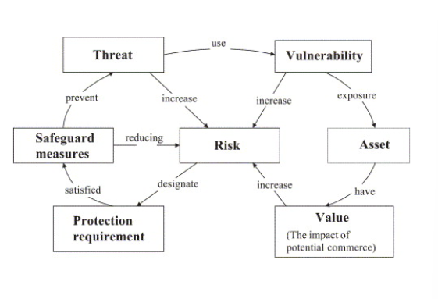

**Approaches to Risk Analysis**

1. Baseline Approach

**Aims:** to implement a basic general level of security controls on systems using baseline documents, codes of practice, and industry best practice.

**Advantages:** does not require the expenditure of additional resources in conducting a more formal risk assessment and that the same measures can be replicated over a range of systems.

**Disadvantage:** no special consideration is given to variations in the organization’s risk exposure based on who they are and how their systems are used.

2. Informal Approach

Involves conducting some form of informal, pragmatic risk analysis for the organization’s IT systems.

No use of formal, structured process but rather exploits the knowledge and expertise of the individuals performing this analysis.

**Disadvantage:** because a formal process is not used, there is a chance that some risks may not be considered appropriately, potentially leaving the organization vulnerable.

3. Detailed Risk Approach

Third and most comprehensive approach is to conduct a detailed risk assessment of the organization’s IT systems, using a formal structured process.

Greatest degree of assurance that all significant risks are identified and their implications considered.

Process involves a number of stages, including identification of assets, identification of threats and vulnerabilities to those assets, determination of the likelihood of the risk occurring and the consequences to the organization if that occurs, and hence the risk the organization is exposed to.

4. Combined Approach

Combines all above approaches

**Aim:** is to provide reasonable levels of protection as quickly as possible, and then to examine and adjust the protection controls deployed on key systems over time

**How to perform risk assessment?**

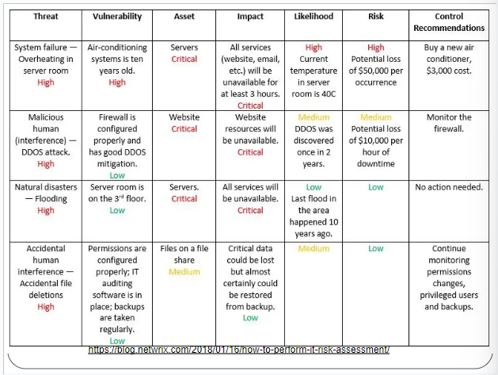

**Business Continuity Plan**

Refers to an organization’s system of procedures to restore critical business functions in the event of an unplanned disaster.

These disasters could include natural disasters, cyberattacks, service outages, or other potential threats.

Enables orgs to resume business operations with minimal downtime

Prime importance to your business to ensure minimum disruption and smooth functioning of your operations.

Consists of the critical information an organization needs to continue operating during an unplanned event.

States the essential functions of the business, identify which systems and processes must be sustained, and detail how to maintain them.

Ensures that personnel and assets are protected and are able to function quickly in the event of a disaster.

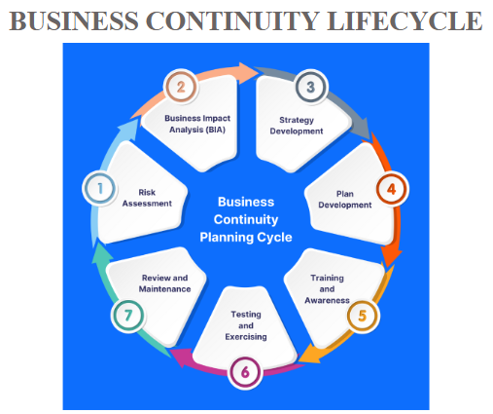

**How does one start with BCM?**1. Business Impact Analysis (understanding the organization)

Would help you to identity critical business systems and processes and how their outage (downtime) could affect your business.

2. Defining the plan (Determining BCM strategy)

Involves identifying potential disruptions to critical processes, such as natural disasters, human-related events, IT failures, or business challenges.

These threats are assessed for severity and likelihood to prioritize critical risks for mitigation.

3. Implementing the plan (Developing and implementing BCP response)

BCPs are developed using identified risks and client-specific requirements, focusing on mitigation strategies, roles, responsibilities, and budget allocation. Implementation includes redundant infrastructure, SLAs, backups, training, and resumption plans to ensure seamless business continuity.

4. Testing and improving plan (Exercising, maintaining and reviewing)

BCPs must be regularly tested through simulations like infrastructure failures, evacuation drills, and backup decision-making.

Test results should identify gaps, inform updates for emerging threats, and be reviewed by senior management to ensure continuous improvement and compliance, including BS22301 certification.

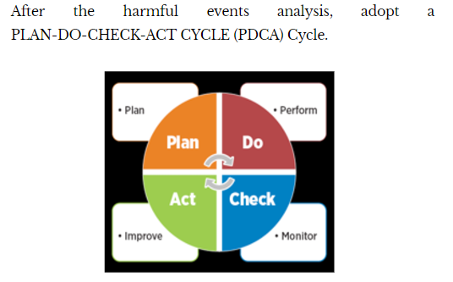

**Business Impact Analysis**

1. RTO: Recovery Time Objective

A standard definition of RTO is the duration of time in which a business process must be restored after a disaster in order to avoid unacceptable consequences associated with a break in business continuity.

1. RPO: Recovery Point Objective

RPO is often defined as the maximum targeted period in which data might be lost from a disaster.

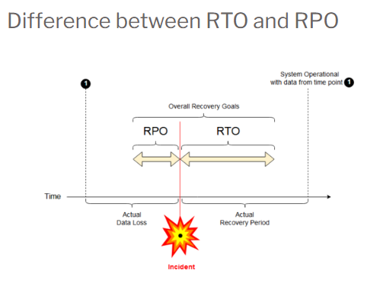

**Incident Management**

**Incident:** an event that causes disruption to or a reduction in the quality of a service which requires an emergency response.

Process used by DevOps and IT Operations teams to respond to an unplanned event or service interruption and restore the service to its operational state.

Includes only those tasks required to mitigate impact and restore functionality.

Incident is resolved when the affected service resumes functioning in its intended state.

**Types of Incidents**

Based on Priorities

1. Low Priority
2. Medium Priority
3. High Priority

Based on Assets

1. Software Incidents
2. Hardware Incidents
3. Security Incidents

**Incident Management Process Workflow**

* **Incident Identification & Logging:** Incidents are identified via user reports or analysis and logged accordingly.
* **Incident Categorization:** Incidents are categorized to guide handling and prioritize resources.
* **Incident Prioritization:** Priority is determined by impact and urgency using a priority matrix.
* **Incident Investigation and Diagnosis:** Staff investigate, diagnose, and determine remediation steps for the incident.
* **Incident Escalation:** Escalation follows incident categorization and can occur transparently if automated.
* **Incident Resolution & Closure:** Threats are resolved, systems restored, and documentation finalized with a review of response steps.

**Roles & responsibilities in Incident Management**

* Level I Support: Handles basic troubleshooting, such as password resets and printer configurations, involving technical staff.
* Level II Support: Manages complex issues like software/hardware troubleshooting and repairs with specialized staff.
* Level III Support: Addresses major incidents and complex problems, relying on the most experienced experts.

**Incident Manager:** Oversees incident resolution to restore normal service quickly and minimize business impact.

**Responsibilities:**

* Plans, coordinates, monitors, and reports on the incident management process.
* Communicates with the Incident Process Owner and acts as the point of contact for major incidents.
* Implements the Incident Management process and handles related reporting.
* Serves as the first escalation point for incidents and monitors Tier 1 Analyst workloads.

**Incident Management Tools**

1. **Monitoring Tools:** Provide continuous insights into infrastructure health and trigger alerts for unexpected activities.
2. **Root Cause Analysis (RCA) Tools:** Systematically identify the root cause of issues to address and prevent recurrence.
3. **Incident Response Tools:** Automate monitoring, identification, and resolution of security issues, including detecting and blocking threats while alerting security teams.
4. **Service Desk Tools:** Facilitate incident logging and tracking.

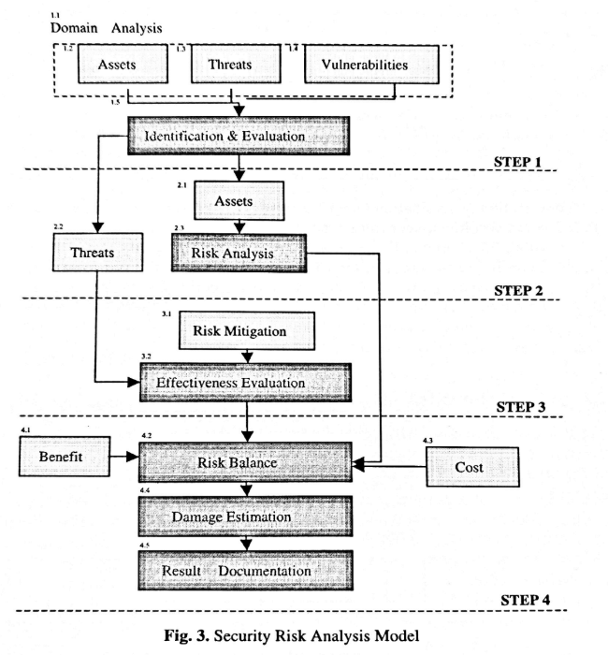

**LEGAL SYSTEM & CYBERCRIME**

* Cybercrime is the use of a computer as an instrument to further illegal ends, such as committing fraud, trafficking in child pornography and intellectual property, stealing identities, or violating privacy.
* Cybercrime, especially involving the Internet, represents an extension of existing criminal behaviour alongside some novel illegal activities.
* A primary effect of cybercrime is financial; secondary effect is affecting Individual private information

TYPES OF CYBERCRIME: Depending on the ways in which computers are used for crimes, Cybercrimes are divided further as:

Cybercrimes wherein Computer is the target

* Virus Dissemination
* DDOS attack
* Potentially Unwanted Programs
* Ransomware Attack

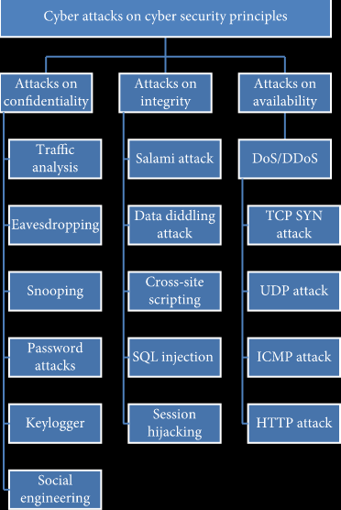

Cybercrimes where Computer is a tool

* Botnet
* Identity Theft
* Cyberstalking
* Social Engineering
* Phishing
* Illegal Content
* Online Scams
* Online Child Abuse

**LEGAL ENFORCEMENT CHALLENGES**

The following challenges can be encountered in legal enforcements of Cyber crimes:

* Jurisdiction
* Poor Knowledge about Prosecution
* Non reporting of Cybercrimes
* Difficulty in Gathering Legal Digital Evidences

**ETHICAL ISSUES IN SECURITY MANAGEMENT**

| AREA | ETHICAL ISSUES |
| --- | --- |
| Technology Intrusion | Privacy internal/external to firm  Computer Surveillance  Employee Monitoring  Hacking |
| Personnel Issues | Employee Interruption  Ergonomics & Human Factors  Training to avoid Job obsolescence |
| Legal & Social Responsibilities | Misuse, fraud, Abuse  Accuracy and timeliness of data  Monopoly of Data |
| Ownership Issues | Proprietary Rights  Conflicts of Interest  Software Copyrights  Personal benefits from company assets  Theft of Data, Software, Hardware |

**ETHICAL ISSUES IN SECURITY MANAGEMENT**

* The ACM Code of Ethics and Professional Conduct
* Strive to achieve the highest quality, effectiveness, and dignity in both the process and products of professional work.
* Acquire and maintain professional competence.
* Know and respect existing laws pertaining to professional work.
* Accept and provide appropriate professional review.
* Give comprehensive and thorough evaluations of computer systems and their impacts, including analysis and possible risks.
* Honor contracts, agreements, and assigned responsibilities.
* Improve public understanding of computing and its consequences.
* Access computing and communication resources only when authorized to do so.

The IEEE Code of Ethics and Professional Conduct:

* To accept responsibility in making decisions consistent with the safety, health and welfare of the public, and to disclose promptly factors that might endanger the public or the environment;
* To avoid real or perceived conflicts of interest whenever possible, and to disclose them to affected parties when they do exist;
* To be honest and realistic in stating claims or estimates based on available data;
* To reject bribery in all its forms;
* To improve the understanding of technology, its appropriate application, and potential consequences;
* To maintain and improve our technical competence and to undertake technological tasks for others only if qualified by training or experience, or after full disclosure of pertinent limitations;
* To seek, accept, and offer honest criticism of technical work, to acknowledge and correct errors, and to credit properly the contributions of others;
* To treat fairly all persons regardless of such factors as race, religion, gender, disability, age, or national origin;
* To avoid injuring others, their property, reputation, or employment by false or malicious action;
* To assist colleagues and co-workers in their professional development and to support them in following this code of ethics.